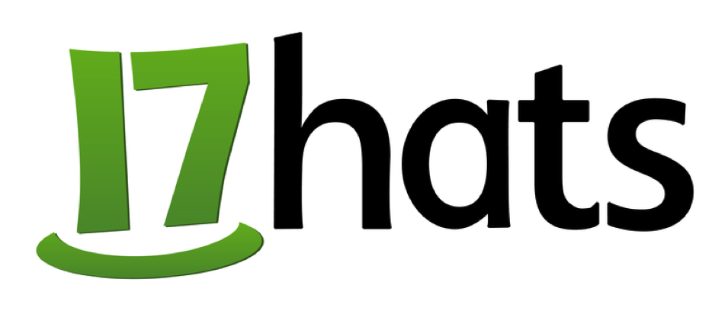
For Immediate Release

U.S.-based 17hats Announces a No-Cost Version of their Business Management Solution for Entrepreneurs

Popular time-saving app now in-use by 17,000+ small businesses, handles
essential tasks like getting paid quickly and adding new clients

Pasadena, CA (September 14, 2016) – Cloud-based business management app 17hats, announced today a restructured pricing plan for its template-driven business service that’s currently in-use by more than 17,000 small businesses. 17hats now offers support for every size business with plans that start at $0 per month and will grow as their client business needs grow.

To get started, users can sign-up at 17hats for access to the new 17hats BASIC plan, which is free for life and which requires no credit card to register. The award-winning 17hats business solution, which allows business owners to save time, get paid quickly and add new clients is also available as a LITE plan for $17 per month and as an UNLIMITED plan for $39 per month. Additional plan details are available at 17hats.

Updated pricing is only the latest big announcement from 17hats. On July 5th, 2016 the company rolled out their revolutionary new service, 17hats Ally, which runs on top of their powerful platform. 17hats Ally gives business owners a virtual and U.S.-based “personal business management team” of three. From client communications to helping with contracts, invoices, and even bookkeeping. Thanks to Ally and their new pricing plans, businesses of all sizes and needs have a partner in 17hats.

“Two years ago we launched 17hats, a behind-the-scenes business solution designed to help our customers by automating the often mundane, day-to-day tasks needed to smoothly run their business operations,” said Donovan Janus, founder and CEO of 17hats. “I’m especially proud that 17hats is now able to offer a full range plans to ensure that our customers can select the right product at the right price for every business even as their businesses grows.”

About 17hats
17hats is a cloud-based all-in-one business management solution built for solo entrepreneurs, freelancers and microbusinesses. 17hats provides a single hub for email communications, quotes, contracts, project management, bookkeeping and more so that entrepreneurs can follow their passion instead of fumbling with multiple tools. Designed to eliminate busywork, the platform also simplifies repetitive tasks with templates and automated workflows. Today, more than 17,000 entrepreneurs use 17hats to get organized, save time and end the chaos of juggling multiple business apps. 17hats is based in Pasadena, California. Learn more at http://www.17hats.com.

# # #

Media Contact:  Steven Rosenbaum  S.I.R. Marketing Communications, Inc. sir@sironline.com  T: 631-757-5665 |  | Company Contact:  Ryan Groves  17hats  ryan@17hats.com  T: 316-737-2646

