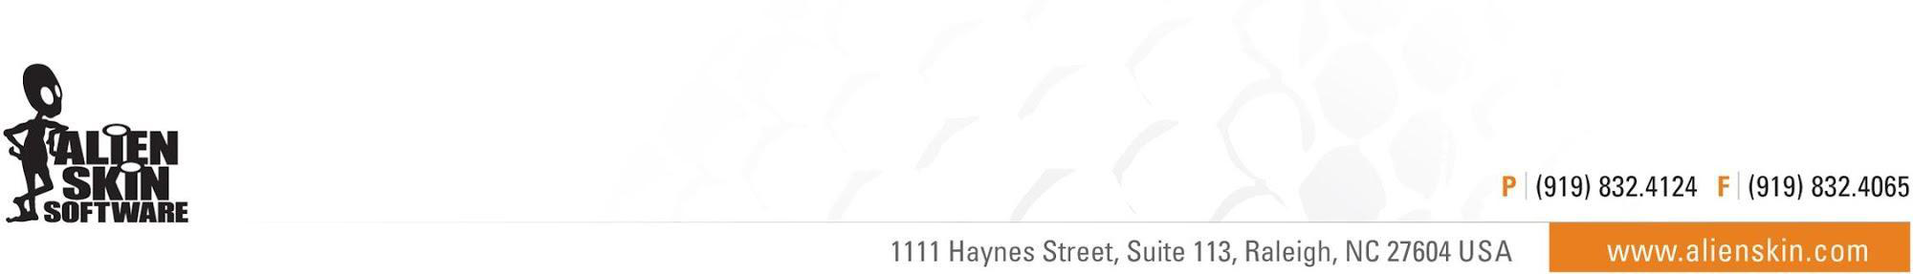

Alien Skin Software Announces Its 25th Anniversary Sale:
Save up to 30% on All Products May 31st through June 5th

Raleigh, NC (May 31st, 2018) - Alien Skin Software today announced the beginning of its 25th anniversary sale. Customers can enjoy savings of up to 30% on all products in its online store from May 31st through June 5th.

Since 1993, Alien Skin Software has been creating advanced, award-winning image editing applications. Their 25th anniversary sale celebrates this milestone.

Alien Skin Software’s flagship product is Exposure, an advanced non-destructive RAW photo editor. Photographers can use it to quickly organize, edit, enhance, and export their photos. Exposure’s design encourages a creative and intuitive workflow complexity. Unlike traditional photo editors, Exposure does not require a subscription to use.

Recent updates to Exposure X3 bring greater control over color and white balance; printing capabilities; improvements to watermarks, collections, and keywords; as well as expanded support for Canon, Fujifilm, and Sony cameras and lenses.

Four additional products are available at a savings of up to 30%:
- Blow Up for creating high-quality enlargements
- Snap Art for transforming photographs into beautiful pieces of artwork
- The Exposure X3 Bundle, which integrates Exposure, Blow Up, and Snap Art
- Eye Candy for graphic design special effects

About Alien Skin Software
Alien Skin Software makes creative tools for photographers and graphic designers. The company distills advanced math and cutting edge research into creative tools that help photographers and graphic designers quickly bring their vision to life. Alien Skin Software’s reputation for bug-free software and friendly tech support has grown worldwide since its founding in 1993. For more information, visit the Alien Skin website at www.alienskin.com.

Exposure, Snap Art, Bokeh, Blow Up, Alien Skin Software, and the Alien Skin Software logo are registered trademarks of Alien Skin Software, LLC. All other trademarks are the property of their respective owners.

# # #
Media Contact: Company Contact:
Steven Rosenbaum Alien Skin Software
S.I.R. Marketing Communications, Inc. press@alienskin.com
sir@sironline.com 919-832-4124
631-757-5665

