NEWS RELEASE
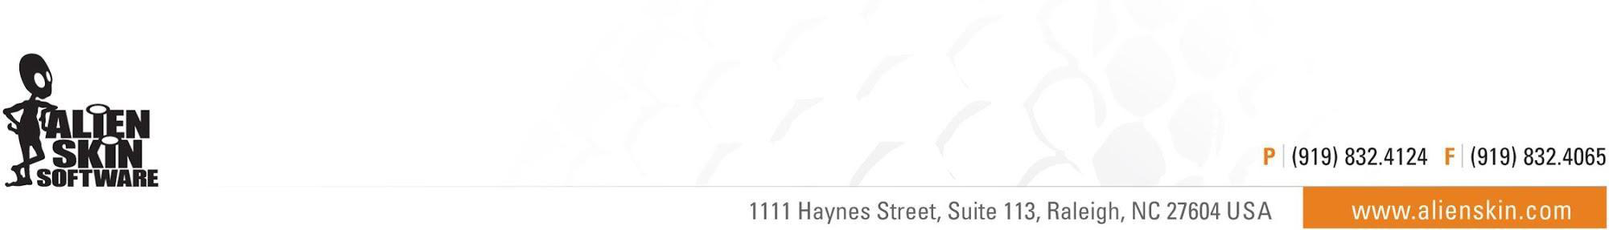

Embargoed Until July 20, 2017, 12:00 AM EDT
Alien Skin Software Announces Summer Sale:
All Products 40% Off

Sale runs from July 20th to July 24th

Raleigh, NC (July 20th, 2017) - Alien Skin Software today announced its summer sale. All products in its store are 40% off through July 24th.

This includes the Advanced Layers Update for Exposure X2, their non-destructive RAW photo editor. Photographers can quickly organize, edit, enhance, and export their photos, while enjoying the speed and ease of a catalog-free workflow. From capture to creativity, Exposure is the fastest way for photographers to bring their vision to life.

Four additional software products are available at a savings of 40%:
- Blow Up for creating high-quality enlargements
- Snap Art for transforming photographs into a beautiful piece of artwork
- The Exposure X2 Bundle combines all Alien Skin’s photo editing applications into one product at the best savings
- Eye Candy 7 for creating spectacular special effects in Photoshop: fire, chrome, lightning, and more.

About Alien Skin Software
Alien Skin Software makes creative tools for photographers and graphic designers. The company distills advanced math and cutting edge research into creative tools that help you quickly bring your vision to life. Alien Skin Software’s reputation for bug-free software and friendly tech support has grown worldwide since its founding in 1993. For more information, visit the Alien Skin website at www.alienskin.com.

Exposure, Snap Art, Bokeh, Blow Up, Alien Skin Software, and the Alien Skin Software logo are registered trademarks of Alien Skin Software, LLC. All other trademarks are the property of their respective owners.

# # #

Media Contact: Company Contact:
Steven Rosenbaum Alien Skin Software
S.I.R. Marketing Communications, Inc. press@alienskin.com
sir@sironline.com 919-832-4124
631-757-5665

