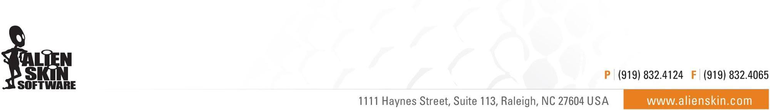

Alien Skin Software Announces Fall Sale:
Savings Of 20% Or More On All Products
Sale runs from November 24th through 27th

Raleigh, NC (November 24th, 2017) - Alien Skin Software today announced the beginning of its fall sale. Customers can enjoy savings of 20% or more on all products in its store today through November 27th.

The featured product is Exposure X3, their non-destructive RAW photo editor. Photographers can quickly organize, edit, enhance, and export their photos, while enjoying the speed and ease of a lightning-fast workflow. Exposure’s unique design streamlines image management and backups, facilitates an adventurous creative workflow, and enables multi-computer collaborative work that is not possible with traditional photo editors. From capture to creativity, Exposure is the fastest way for photographers to bring their vision to life.

Four additional software products are available at a savings of 20% or more:
- Blow Up for creating high-quality enlargements
- Snap Art for transforming photographs into beautiful pieces of artwork
- The Exposure X3 Bundle integrates Exposure, Blow Up, and Snap Art for a low price
- Eye Candy 7 for graphic design special effects

About Alien Skin Software
Alien Skin Software makes creative tools for photographers and graphic designers. The company distills advanced math and cutting edge research into creative tools that help you quickly bring your vision to life. Alien Skin Software’s reputation for bug-free software and friendly tech support has grown worldwide since its founding in 1993. For more information, visit the Alien Skin website at www.alienskin.com.

Exposure, Snap Art, Bokeh, Blow Up, Alien Skin Software, and the Alien Skin Software logo are registered trademarks of Alien Skin Software, LLC. All other trademarks are the property of their respective owners.

# # #

Media Contact: Company Contact:
Steven Rosenbaum Alien Skin Software
S.I.R. Marketing Communications, Inc. press@alienskin.com
sir@sironline.com 919-832-4124
631-757-5665

