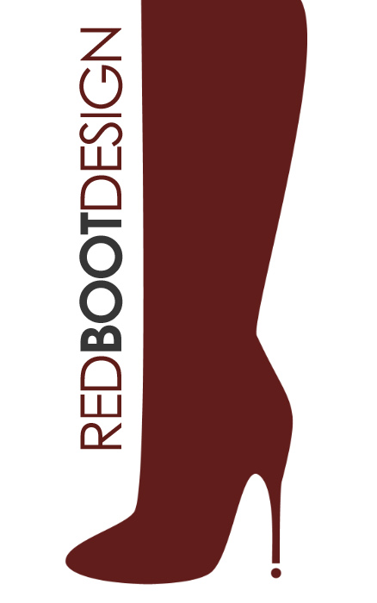
FOR IMMEDIATE RELEASE

Red Boot Design Adds New AsukaBook Design Templates
Now offers the best of both worlds – custom one-of-a-kind designs and convenient templates
Las Vegas, NV, WPPI 2010 Booth #1619 (March 8, 2010) – Red Boot Design, a Division of Kubota Photo Design, Inc., is pleased to announce that they have added several new AsukaBook album design templates to their list of products. Red Boot Design will continue to specialize in one-of-a-kind custom album designs, but now also offers the convenience of design templates for photographers who want to create an album quickly and effortlessly on their own.
“Red Boot Design has always taken pride in providing an important service that allows photographers to save time and focus more on capturing images,” said Lindsey Cox, lead designer of Red Boot Design. “Now, we’ve taken our creative service one step further by providing custom album design and album templates for purchase. Whether a photographer is looking for a unique, one-of-a-kind album, or a convenient template they can use over and over, we’ve got them covered.”
AsukaBook album templates start at $30, and feature a variety of styles and popular themes such as wedding, baby, senior, family, and more. Now, more than ever, there is a template to meet the needs of every photographer. The templates will be fully editable in Photoshop® to allow photographers to edit the designs to the needs of their individual clients.
About Red Boot Design
Red Boot Design and AsukaBook USA offer a complete turnkey high-quality album solution for photographers with the utmost convenience. Photographers simply send Red Boot Design their high resolution digital image files, and their experienced designers create a tasteful layout that exhibits the photographers’ work to its fullest artistry. The layout can then be immediately sent to AsukaBook for print production. Red Boot Design also designs for any other album company, always leaving the choice to the individual photography studio.

-more-
Whether the photographer’s specialty is photographing weddings, portraits, or landscapes, Red Boot Design will keep them behind the lens. For more information view their gallery at http://www.redbootdesign.com.

# # #

Contact: Lindsey Cox Steve Rosenbaum/Leigh Nofi Red Boot Design S.I.R. Marketing Communications, Inc. (866) 723-7540 (631) 757-5665 lindsey@redbootdesign.com sir@sironline.com or leighnofi@sironline.com

