For Immediate Release

DxO Labs Brightens the Winter
With New DxO Lighting Flickr Toy

FREE DxO Lighting Flickr Toy automatically brings more pop to any digital photo stored on Flickr.com or on any computer connected to the Internet

Paris, France – January 18, 2007 – Digital photographers can get even more out of their photos by using the FREE DxO Lighting Flickr Toy, available immediately from FD’s Flickr Toys website, http://bighugelabs.com/flickr/. Provided in partnership with John Watson’s FD Flickr Toy website, the DxO Lighting Flickr Toy brings DxO Lighting - the award-winning automatic local exposure and dynamic range optimization technology from DxO Labs - to digital photographers worldwide. The DxO Lighting Flickr Toy is free of charge and works directly online in an easy to use, two step process.

Created by John Watson in 2005, FD’s Flickr Toys (http://bighugelabs.com/flickr/) features hand-selected, fully-tested fun accessories, toys and amusements for digital photographers in general as well as toys and utilities specifically for photographers using the Flickr.com site to store, search, sort and share digital photos. “We’re really excited about the partnership with Flickr Toys,” says Luc Marin, VP of DxO Labs Photography business. “John Watson tests every tool and utility he offers and we’re proud to be the latest of the fun and useful tools offered on his site.”

Digital photographers can experience the spectacular improvement DxO Lighting Flickr Toy makes to their images by following a simple, two-step process: 1. Select an image from their Flickr account, hard disk or any website, and 2. Using just two sliders, adjust the strength of the DxO Lighting magic. A dynamic preview image shows the before and after results.

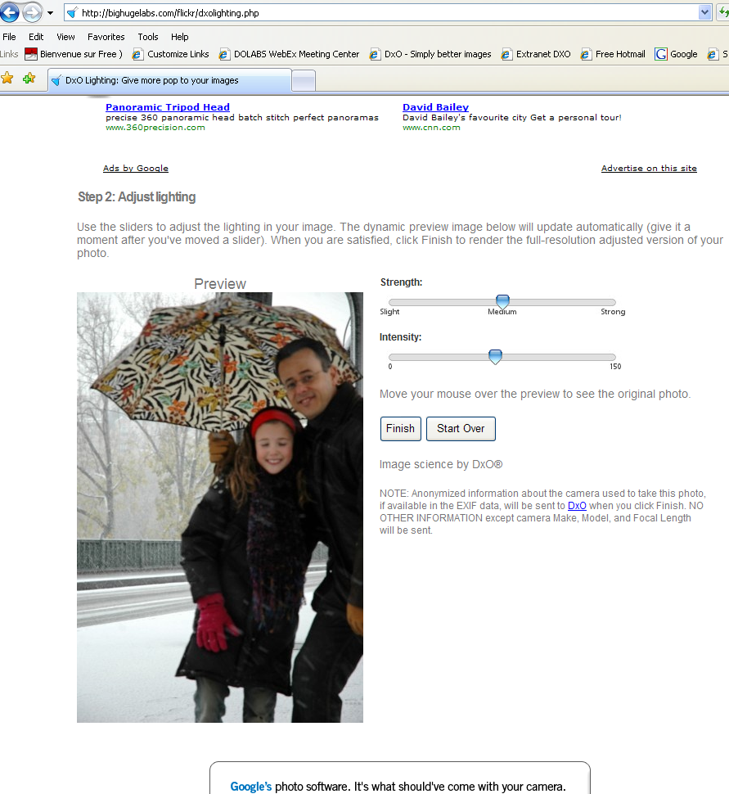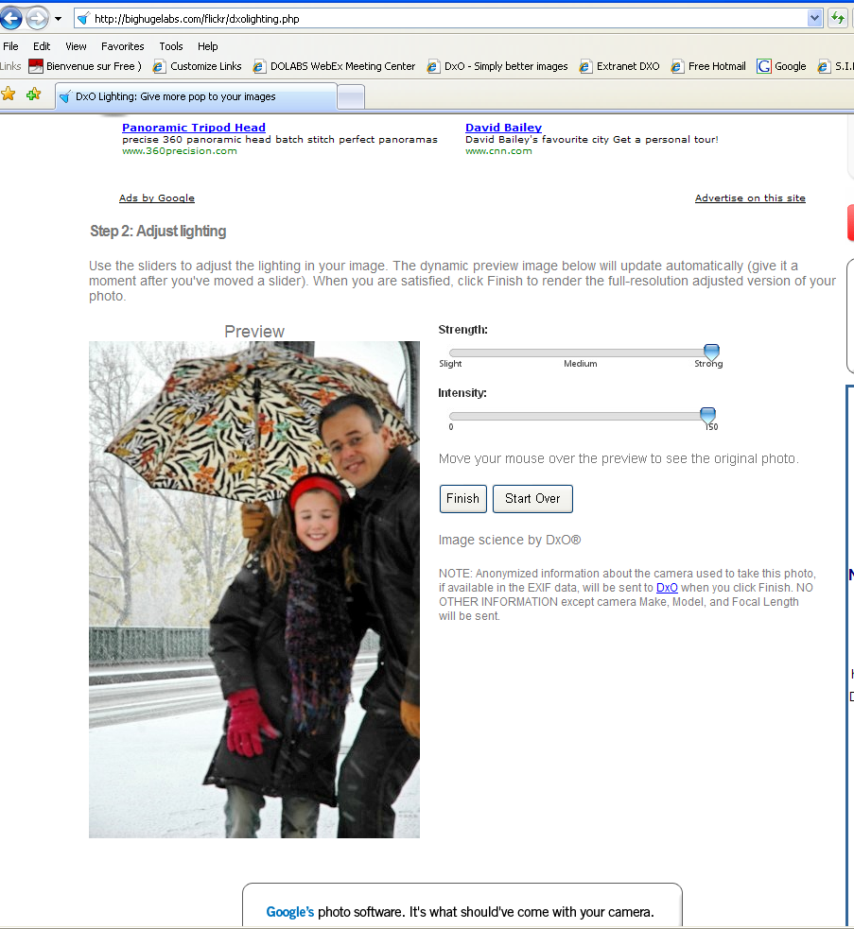

“The DxO Lighting Flickr Toy is a fun, easy way to introduce digital photographers to the powerful correction capability of DxO Optics Pro,” says Luc Marin,

Photographers interested in experiencing more of DxO Labs unique Image Science capabilities can download a free demonstration version of DxO Optics Pro the company’s flagship product for demanding photographers at www.dxo.com.

About DxO Labs
DxO Labs develops and licenses software IP and silicon IP for embedded architectures for still and video image processing. DxO Labs invests extensively in research in applied mathematics and, as a result, has acquired unique savoir-faire across the entire imaging chain. This expertise enables DxO Labs to provide reliable, state-of-the-art technologies that power excellence in all aspects of image quality.
The products in DxO Labs’ portfolio not only provide outstanding features, they produce substantial system cost reductions and are steadily finding a place at the heart of consumer electronics and advanced imaging systems. The company’s key customers and partners encompass:
- Consumer electronics manufacturers such as digital camera vendors, camera phone vendors, laptop vendors;
- Industry imaging components suppliers such as camera module manufacturers, sensor vendors, processor vendors;
- Demanding photographers as well as photography journalists and imaging experts.
DxO Labs’ ambition is for the “Image Science by DxO” brand to become an undisputed, trusted mark of excellence in image quality and a new reference standard for consumers and the leading companies in the imaging business.
For more information, visit www.dxo.com
In North America, DxO Optics Pro is available through Calumet Photographic (www.calumetphoto.com) and Adorama Camera (www.adorama.com).

Press Contact Information
Deborah Gallin Steve Rosenbaum / Leigh Nofi
DxO Labs SIR Marketing Communications, Inc.
France USA
+ 33 1 55 20 55 99 + 631-757-5665
pressrelations@dxo.com sir@sironline.com

DxO Labs, S.A. 3, rue Nationale 92100 Boulogne France
DxO is registered trademarks of DxO Labs. Other trademarks and trade names may be used in this document to refer to either the entities claiming the marks and names or their products. DxO Labs disclaims any proprietary interest in trademarks and trade names other than its own.

