

October 2005

An Introduction To DxO Noise Engine

CONTENTS:

What is noise?

How does DxO Noise works?

HOW DOES DxO Noise WORKS in DxO Optics Pro?

WHY IS DXO NOISE UNIQUE?

DxO Noise BENFITS for PHOTOGRAPHERS

DxO Noise versus competition

What is noise?

Noise is a random variation of the pixel values across the image which significantly impacts image quality. It is particularly acute when the digital camera is set to high ISO speeds. Noise is essentially visible in uniform areas (typically faces, blue skies and shadow areas with no details) and appears as a combination of brightness and color grain patterns.
Brightness noise, which looks a bit like film grain noise, is also referred to as luminance noise. The color noise consisting of little color spots particularly visible in shadow area is called chrominance noise.

There are a number of noise sources, the physical nature of light and the sensor being the primary ones. The sensor noise itself has many origins, readout noise, photo-site noise, random noise, dark current, just to name the most important.
Noise is either categorized as temporal or spatial. Temporal noise varies from one image to another, while spatial noise consists in a fixed pattern that stays the same from frame to frame.
Noise in digital cameras is quite complex and produces an image degradation that is quite difficult to accurately characterize, and to remove. In addition it is very much dependant on the sensor type (CCD versus CMOS) and pixel size. As an example, the following images show different noise patterns to illustrate temporal noise and fixed pattern noise; the later being specific to CMOS sensor.

Temporal noise | Spatial fixed pattern noise (CMOS)
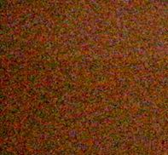 | 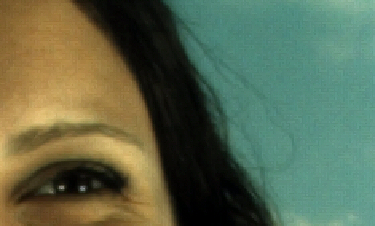
Fig 1: Temporal and spatial sensor noise examples

In addition noise amplitude and pattern change with ISO speed setting of the digital camera as shown on figure 2.

The ever decreasing size of pixels creates a need to deliver more and more powerful noise removal techniques, as the noise level is inversely proportional to the pixel size.
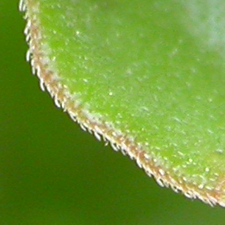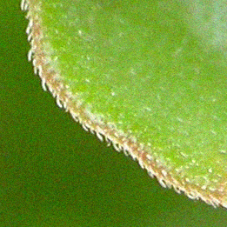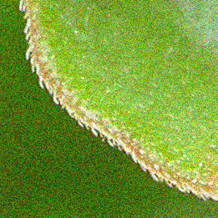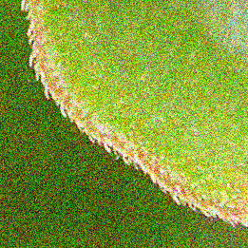
ISO 100
ISO 200
ISO 400
ISO 800

Fig 2: noise varies with ISO speed

How does DxO Noise works?

The most common noise reduction technique is to replace each pixel value by the average of the values of its neighbors, it then reduces the local variation due to random noise but at the same time it smoothens details out leading to much less sharpness into the image.

DxO Noise breakthrough algorithm is based on the most recent mathematical research: the “non local means of similar neighborhoods image denoising method” as it is scientifically known. This class of algorithm looks for correlations in the image data corresponding to real features from the scene, so that the real features can be distinguished from uncorrelated random noise. Such technique relies on sophisticated noise models that result from in-depth analysis of sensor behavior. Once the distinction between details and noise is performed, some type of selective filter is applied to remove noise signals while preserving details.

To that end, at DxO Labs, we have developed a sensor calibration based method, to feed our noise removal engine with the best possible noise model.
We believe this strategy, similar to our Optics fault correction strategy, delivers the best possible results in terms of removing defects and preserving the structure and richness of images.

DxO Noise Engine is therefore a hardware-model based correction, the correction algorithm is specifically tailored by DxO Labs for each camera, and so this correction will only be performed for images from cameras that have been calibrated by DxO.

More and more cameras are being profiled as time goes by. Generally, DxO Noise achieves a 2 stop gain in image noise level. So for example, an image shot at 1600 ISO and processed by DxO Noise, will display the noise level of an image shot at 400 ISO (see fig 3).

35
29
3200
38
33
1600
40
35
800
41
38
400
40
40
200
41
41
100
SNR
SNR
ISO
DxO corrected
picture

Original picture

+ 2 stops

Fig 3: noise varies with ISO speed

HOW DOES DxO Noise WORKS in DxO Optics Pro?

- In ‘automatic mode’, DxO Noise provides an optimum balance between all the possible correction parameters. This optimum correction has been achieved after extensive camera testing and large image database analysis performed at DxO Labs.

- In ‘Expert mode’, DxO Noise gives access to a Luminance noise correction, Chrominance noise correction, Impulse noise correction and Grey equalizer sliders.
- Luminance noise/Chrominance noise correction: Since the eye typically sees small details more in luminance and is particularly annoyed by chrominance noise, good setting are generally found with a medium value for Luminance noise correction and a large value for Chrominance noise correction.
Higher values of Luminance noise correction may produce some loss of sharpness; one can improve this result by applying an unsharp mask with a narrow radius and a high amount (available in the Sharpening tab of the ‘Expert Controls’ mode).

- The Impulsive noise (random pick values –brighter spots- randomly distributed across the image) correction slider enables user to tune the strength of impulsive noise correction. Impulsive noise is typically present on jpeg images of some cameras (Canon 1DS, Canon1DSMKII, and Canon 300D).

- The Gray equalizer slider allows thr user to de-saturate grey or neutral parts of the images. Indeed, on these parts, the eye is sensitive to very low color noise. This control makes it possible to ‘clean up’ unwanted colored noise from midtones, and has the effect of slightly desaturating neutral tones around mid-gray, to minimize spurious color effects in these sensitive areas. You will probably be able to leave it at the default setting, unless you notice the effect it can have of desaturating certain pastel tones.
In order to judge the effect of your noise adjustments, it is essential to use the Zoom tool, which gives an accurate preview of final image quality. Choose an area of your image where you can best assess the noise to make your adjustments, and then if necessary move the zoom area around in order to examine other critical areas.

Here follows a set of pictures to illustrate the effect the DxO Noise reduction; the chrominance noise has been almost entirely removed while luminance correction has been balance to ensure details are preserved: particularly one would notice that the very fine eye lashes are quite nicely preserved with DxO Noise, that’s the real challenge Noise reduction software has to deal with!
Without correction | 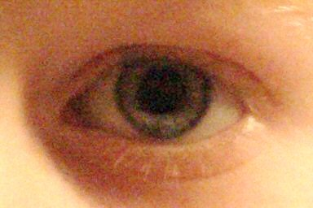
After DxO Noise correction | 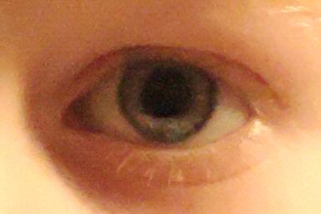
Fig 4: Sample images of DxO Noise in action

WHY IS DXO NOISE ENGINE UNIQUE?

- DxO Noise calibration is performed by DxO Labs, based on the company’s know-how developed for the already famous DxO Analyzer, ensuring a high precision mathematical characterization and enabling a high discrimination between noise and signal. This characterization takes many capture parameters into account. Among them:
  - ISO speed rating
  - Grey level: images usually have more noise in shadow areas than highlight areas.
  - Camera body sharpening
- Noise removal is performed at raw conversion level (for raw images), and takes into account raw conversion settings such as Ev bias correction.

Both key features ensure optimal noise removal while maintaining image sharpness.

DxO Noise BENFITS for PHOTOGRAPHERS

Figure 3 showed that DxO Noise achieves a 2 stop gain in image noise level. In fact, this means that a “DxO Noise corrected picture” needs 4 times less light than an uncorrected image to deliver identical image quality.
When taking pictures, this translates into a combination of the following opportunities opening more flexibility and creative freedom for photographers:
- Shutter speed can be increased, to ensure motion blur reduction
- Aperture can be reduced, to ensure image softness and vignetting reduction, while increasing the depth of field.

About DxO Labs and its DxO Technology
DxO Labs is a software company developing image generation and enhancement technologies. We provide reliable off-the-shelf solutions for serious amateurs and professional photographers, photography journalists and experts as well as companies in the imaging business such as digital camera or cameraphone vendors, mobile operators, and printing or photofinishing professionals.
The company's patented DxO technologies, the DxO Technology Foundations, are the result of state-of-the-art academic mathematical research. The DxO Technology Foundations comprise a set of software components to generate images or correct major imaging defects, such as color, contrast, blur, various optics faults, JPEG artifacts, etc.

For more information, visit DxO Labs online at www.dxo.com

Press Contact Information
Deborah Gallin Steve Rosenbaum / Leigh Grimm
Press and External Relations SI.R. Marketing Communications, Inc. (U.S.A.)
DxO Labs (France) + 631-757-5665
+ 33 6 24 47 45 61 (cell) sir@sironline.com
pressrelations@dxo.com
DxO Labs, S.A. 3, rue Nationale 92100 Boulogne France
DxO is registered trademarks of DxO Labs. Other trademarks and trade names may be used in this document to refer to either the entities claiming the marks and names or their products. DxO Labs disclaims any proprietary interest in trademarks and trade names other than its own.

